IMPORTANT NOTICE – ACADEMIC INTEGRITY

This document is part of an active academic competition and graded assessment.
The use of artificial intelligence tools, including but not limited to ChatGPT, Bard, Claude, or other large language models (LLMs), is permitted only if explicitly acknowledged and properly cited.
By accessing or attempting to answer any part of this document, you confirm that:
- the work is completed independently and reflects your own understanding,
- any use of AI or LLM-based tools was limited to support purposes (e.g. clarification, language assistance, or structuring),
- all AI-assisted content is clearly disclosed, including the name of the tool and a brief description of how it was used,
- no AI system was used to generate final diagnostic reasoning or medical conclusions without critical human evaluation.
Failure to disclose the use of AI or submitting fully AI-generated content without citation will be considered academic misconduct and may result in disqualification.
The organizers reserve the right to assess submissions for originality and academic integrity.

ROUND 3 INTERNAL MEDICINE

SECTION 1: Nephrology

Case Study I (20 pts)
A 52-year-old male presented to the emergency department with severe right flank pain radiating to the right lower quadrant. His blood pressure was 154/96, pulse rate was 79 bpm, respiratory rate was 24 breaths per minute and temperature was 36.7° C. The pain was insidious in onset and had an intensity of 10/10 on a verbal analog scale which decreased to 8/10 after administration of Toradol and Morphine medications provided in the emergency department. The pain was constant, lasting 3 hours in duration, and he had two episodes of emesis since its onset. He did not report experiencing any chest pain, dyspnea, fever, or bowel and bladder dysfunction.
His medical history included a similar pain in the left flank two years earlier which was diagnosed as kidney stones.

Physical Examination
His heart rate and respiration were within normal limits. He did not display any signs of edema or nausea, abdominal discomfort, or indigestion. His abdomen was soft with diffuse tenderness which increased over the right lower quadrant. Urinalysis revealed a moderate increase in specific gravity (1.030), significant hematuria (3+), and a trace of protein.

Diagnostic Imaging
A right ureteric calculus was apparent on a conventional abdominal radiograph (Figure 1c). He was discharged from the emergency department with the hope that he would then pass the stone naturally. Unfortunately, the following day, the patient returned reporting that the medications did not significantly affect his pain, and his referral to the urology department was expedited. A computerized tomography (CT) scan was subsequently obtained which revealed a 7mm calcific density in the right proximal ureter with associated moderate hydronephrosis and perinephric stranding (Figures 1a and ​and 1b). Multiple 1–2mm non-obstructing calculi were additionally noted in the left renal parenchyma. The patient was diagnosed with a right ureteric calculus and was managed further with pain (Ketorolac, Morphine, and Naproxen) SSand antiemetic medications.

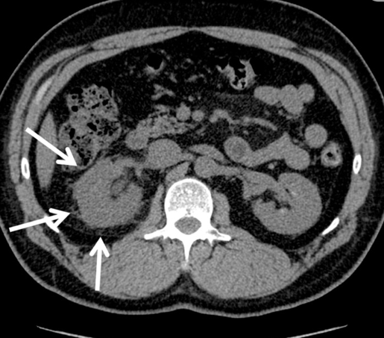
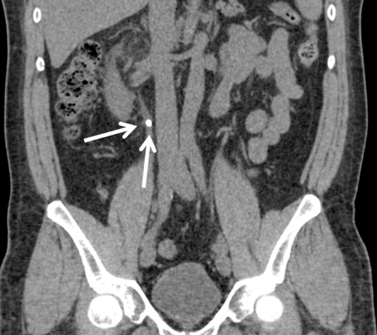
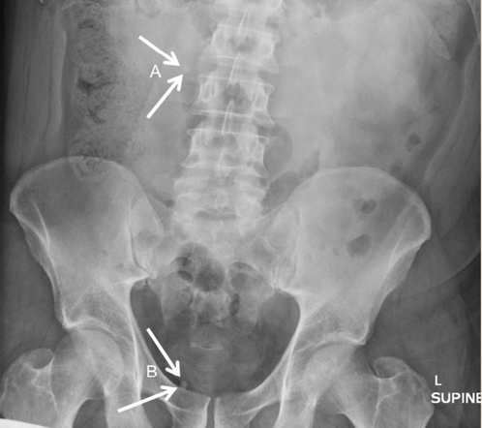
a
b
c

Figure 1. (a)Coronal CT indicating a calcific density in the right proximal ureter. (b) Axial CT indicating hydronephrosis and perinephric stranding in the right kidney. (c) Abdominal radiograph indicating a ureteric calculus (A) and a pelvic phlebolith (B).

The consulting urologist concluded that because his symptoms were refractory to analgesics, and because the calculus was unlikely to pass on its own, emergency laser lithotripsy was indicated. At the time of this procedure, his urine appeared murky and was presumed to be infected and the lithotripsy was abandoned. As an alternative, a ureteric stent was placed to help drain the dilated and infected collecting system. Antibiotics and Tamsulosin were additionally prescribed. The patient was scheduled for stent and calculus removal two months later and instructed to attempt the natural passage of the stone during this period.

Questions:

- What is the mechanism for calculus formation? ( 3 pt)

- Explain 3 factors that increase an individual’s risk for calculus development. (6 pt)

iii. What are the preventive measures for calculus formation? List 4. (4 pt)

iv. Describe 3 methods of diagnosis for kidney calculus. (3 pt)

v. What are the management options? (4 pt)

SECTION 2: Endocrinology

Case Study II (15 pts)
You and your partner, both EMTs, are dispatched to a local shopping mall for a patient with altered mental status. You arrive to find a 52-year-old male sitting in a wheelchair in the care of his wife. She reports the patient “was fine a half hour ago, but is not acting like himself now.” During your primary exam, you note the patient is conscious and knows his name but is confused as to time, place, and event. He is able to follow commands. He has a strong and rapid radial pulse, and his skin is cool, slightly pale, and slightly diaphoretic. His respiratory rate is normal with a good tidal volume, and he is in no respiratory distress. When asked about a chief complaint, he repeatedly responds, “I don’t know what happened.” You immediately radio dispatch and request ALS support.

The patient’s wife informs you that he is a type 1 diabetic and that he ate his normal breakfast this morning and took his usual dose of insulin. She further states that he is routinely compliant with his diet and insulin treatments and has not had “any issues with his sugar for a couple of years.” Your physical exam does not reveal any signs of trauma. You note that his pupils are slightly dilated bilaterally, equal, and reactive to light. His lung sounds are clear and equal bilaterally. He has no facial droop, his speech is not slurred, and he has no neurologic deficits. While examining his lower extremities, you determine he has cellulitis on his left lower leg extending from his foot to midway up the calf. You also note an ulcer on the dorsal surface of his foot that appears to be infected, with a purulent discharge from the wound. The patient’s wife says the ulcer is chronic but that the infection and cellulitis “have gotten worse over the past couple of days.”

His vital signs are heart rate 102, strong and regular; blood pressure 132/84 mmHg; respiratory rate 12/min with good tidal volume; and pulse oximetry 97% on room air.

Your local scope of practice as an EMT does not include the use of a glucometer to determine the patient’s blood glucose level, but local protocol allows the administration of oral glucose. You determine the patient is able to both protect his airway and follow commands, then have him self-administer 15 g. Within five minutes you note he is now alert to person, place, and time. You explain to the patient that he had an episode of hypoglycemia and suggest he go to the emergency department for evaluation. He thanks you for responding and correcting it but says he does not wish to be transported at this time.

Questions:

- Prior to the patient’s improvement with the administration of glucose, what would have been your best guess as to which was more likely, hypoglycemia or hyperglycemia? (4 pt)

- What are the possible factors contributing to his present condition? Which signs indicate the same? (4 pt)

- What is the prehospital management of the conscious patient with hypoglycemia? (5 pt)
- What criteria should be met in order to support this patient’s wish to refuse transport? (2 pt)

Case Study III (15 pts)

The patient is a fourteen-year-old female, Emma who presented to the clinic for bilateral hip and lumbar back pain. She stated that the pain has been present for approximately seven months and described it as a deep ache in the low back and both hips anteriorly. The patient said she plays a variety of sports but denies any specific event that could contribute to her pain. She stated her pain is worse with prolonged walking, standing, and sitting. Additionally, the patient mentioned her first menstrual cycle lasted fifty-six days and she has since not had any following menses, indicating secondary amenorrhea. Secondary amenorrhea is characterized by the cessation of irregular menses for six months and is commonly caused by hormonal imbalances.

Physical examination:
Examination of the hip, abdomen, and back did not demonstrate any deformities. She had tenderness to palpation at the mid-abdomen and at the insertion of the hip flexors, at the ASIS and AIIS bilaterally. Her patellar reflex was normal and 5/5 strength in hip flexion, extension, and abduction was observed along with a full range of motion of both hips. FABER and FADIR tests were conducted and resulted in a positive sign of pain for both tests.

Differential Diagnoses:
Hip dysplasia, Slipped capital femoral epiphysis, Polycystic Ovarian Syndrome, femoroacetabular impingement, and Snapping hip.

Tests and Results:
The patient had an x-ray of both hips that was negative for tissue abnormalities. A pelvic MRI suggested small areas of sub-chondral sclerosis and possible polycystic ovaries.
Questions:

- What is the final diagnosis? Describe in detail. (3 pts, 1 for correct diagnosis, 2 for description)

- What are the criteria for confirming this condition? What are the factors that can cause it? (5 pt, 2pts-2 criteria, 3 pts-3 factors)

- What will be the management course? (preventive, therapeutic, physical, etc) (4 pt)

- What should be the follow up and which departments would you refer to for the patient? (3 pt)

