ROUND 2 DERMATOLOGY

Case Study I: (15 pts)
Author: Tanvi Toprani

- A 570 g female infant was born at the 25th week of gestation by Caesarian section with Apgar scores 7, 9, and 9. The pregnancy was complicated by maternal chorioamnionitis at the time of delivery. The infant was intubated, ventilated, and received surfactant because of respiratory distress syndrome. An umbilical catheter was placed in the first hours of life. Systemic antibiotic therapy was initiated with cefotaxime which was discontinued at day 7 when she was extubated. You are consulted for evaluation of non-healing cutaneous erosions present on the abdomen and left flank since birth. These were thought to be secondary to the trauma of childbirth; however, concern increased when they did not improve over time. Relevant history included prior maternal HSV labialis, quiescent at the time of birth.

Physical Exam
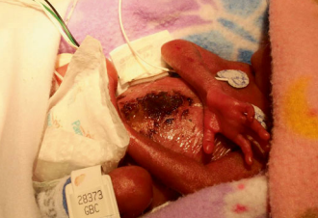
Figure 1. A premature neonate with superficial adherent hemorrhagic dried crust on the central midline abdomen with notable circinate sparing of the umbilicus. The left flank exhibited re-epithelialized erosions.

Vitals: Heart rate 153bpm, blood pressure 46/24, O₂ saturation 94 %.
Lab works: Blood cultures: negative, Placental pathology: no organisms noted. Fusion of placenta

- What is your differential diagnosis? (2 pts)

- What is the final diagnosis of the infant? (2 pt)

- What are the most likely causative organisms for the same? (3 pt)

- Would you like any additional tests? (4 pt

- What treatment would you consider? (4 pt)

Case Study II: (15 pts)
Author: Tanvi Toprani

- A 19-year-old girl who underwent a fully matched unrelated donor bone marrow hematopoietic stem cell transplant ( HSCT ) for acute myeloid leukemia (AML) presented with a full body rash 33 days after HSCT. The new rash was first noted at 31 days after HSCT, initially involving the chest with subsequent spread to the face, arms, and legs. She endorsed mild pruritus, and denied skin tenderness, eye discomfort, or dysuria. She denied any new medications in the last 2 weeks, upper respiratory symptoms, or any sick contacts. She denied abdominal pain, diarrhea, nausea, or vomiting. She had received systemic corticosteroids, cyclosporine, and a short course of high dose methotrexate for prophylaxis against graft-versus-host disease (GVHD) .

Physical Exam
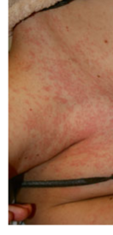
On physical examination, the patient appeared ill but in no acute distress. There were scattered 1–2 mm erythematous macules and papules predominantly on the central chest, upper back, face, ears, palms, soles, and legs. There was no involvement of the oral or ocular mucosa.
B
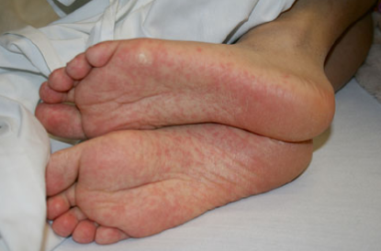
A

Figure 2. (A and B)Scattered 1–2 mm erythematous macules and papules scattered on face, trunk, and extremities with involvement of palms and soles consistent with acute GVHD of the skin.

Labs Works
  - Aspartate aminotransferase (AST) 72 unit/L (10–40 IU/L)
  - Alanine transaminase (ALT) 196 μ/L (7–56 IU/L)
  - Total bilirubin 0.8 mg/dL (0.3–1.2 mg/dL)
  - Blood urea nitrogen (BUN) 19 mg/dL (5–18 mg/dL)
  - Creatinine 0.8 mg/dL (0.5–1.2 mg/dL)

- The symptoms indicate which condition? (2pt)

- What are the classic morphologic patterns of acute GVHD? What are the other primary clinical features? (5pts)

- What is the differential diagnosis for acute GVHD and what is the utility of skin biopsy?(4pts)

- What is the treatment plan? (4 pts)

Case Study III: (20 pts)
- A 21-year-old patient visited the dermatologist with a persistent issue. She had been on a vacation by the sea but had spent most of her time tanning by the pool. She was tanner than she was used to, and only used a minimum amount of SPF with insufficient UV rating. After her return from the vacation, she developed flat non-itchy hypopigmented patches on the back and upper limbs (see the picture). After scratching, pieces of skin peel off in fine, dry flakes. She received a recommendation for cosmetic products in the form of a shower gel from her GP, but they did not work, so she decided to visit a specialist. She does not suffer from any chronic or autoimmune disease, and she has no known genetic mutations. All blood tests were negative, including CRP. A skin swab did not confirm the proliferation of Staphylococcus aureus bacteria. These deposits appeared on the skin:

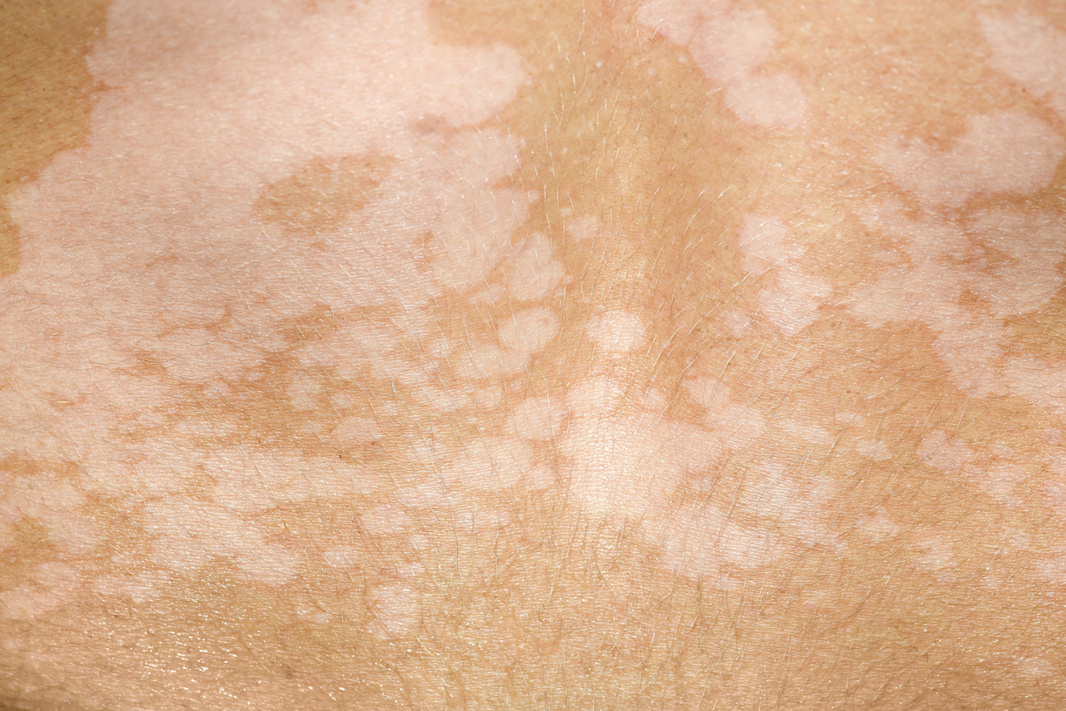
Figure 3.

- What do you believe to be the diagnosis?
- Based on what data? (1 pt)
- What causes the disease? (1pt)
- Why are there lighter patches on the skin? What substance causes those? (2 pts)

2. Hypopigmented patches can be connected to other cutaneous diseases – perform differential diagnostics. (3b)

3. Describe a method you would use to confirm the diagnosis. (1.5 pt)

4. Can the disease present itself via different cutaneous deposits? If so, describe them. (1.5 pts)

5.What other diagnostic methods are used in dermato-venereology? Name at least 3. (1.5 pts)

6. This disease is relatively easily treated.
- Name the class of medication used to treat diseases caused by the same group of agents. (0.5 pt)
- Name a concrete example of medication from this group. (0.5 pt)
- What additional treatment would you recommend? (1 pt)
- What medication would you use if the disease proved to be resistant/recurrent? (1 pt)
- What diseases increase the risk of contracting this infection? (1 pt)

7. Are there any groups of people more susceptible to developing the disease?
- Name at least 2 predisposition factors. (1 pt)
- Where in the world does the disease usually occur? (0.5 pt)

8. Why is it important to use SPF, especially during the summer? (1 pt)
- What mutations can be caused by UV exposure? (0.5 pt)
- Could the patient have not contracted the disease had she used an SPF lotion with a better UV filter? Provide reasoning. (0.5 pt)

